**Story 1 - Take a payment from the enduser and credit the amount to client after 2.4% fee deduction.**

As a **API consumer** I want to **take payment from customer and payout to the client after deduction of 2.4% fee and also record each transaction in database** So that **I can view the total money made by Datman and the money need to pay out the Clients**

**Acceptance criteria**

* Accept client_id, ref_no, amount, currency as a **Required parameter**.
* line_items, vat, service_tax **Optional parameter**.
* If vat and service_tax are provided then fee collection should happen excluding these amount.
* Return status ok with some unique reference after successful transaction.

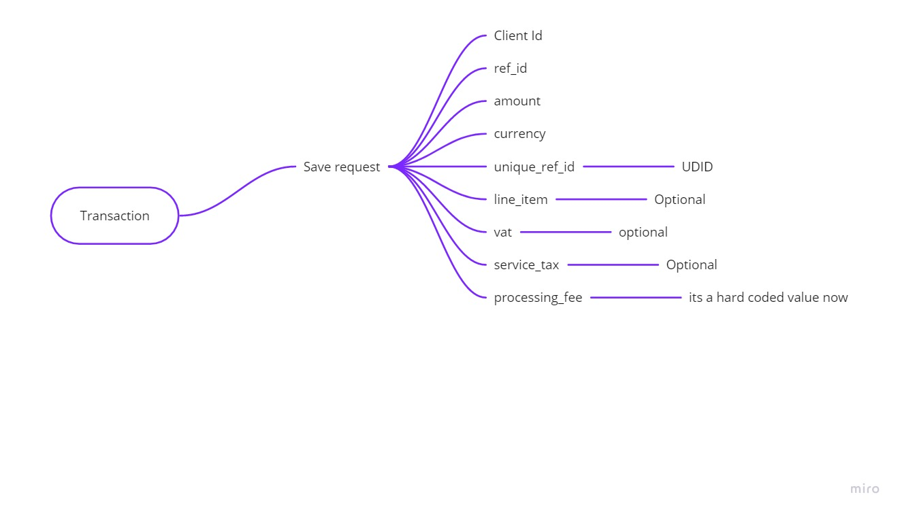

Tables:

|  |  |
| --- | --- |
| **Transactions:** |  |
| ref_no  currency  amount  client_id  line_items  vat  service_tax  processing_fee  trans_ref_no  status |  |
| **Log** |  |
| IP address |  |
| GEO Location |  |
| Useragent |  |
| Timestamp |  |
| Trans_ID |  |

/transaction

Params:

**Case 1:**

{“client_id”:”336773637”,”ref_no”:,amount”:,”currency”:””}

**Case 2 :**

{“client_id”:”336773637”,”ref_no”:””,amount”:””,”currency”:”USD”,”line_items”:””,”vat”:,”service_tax”:}

To Run our app

**Sails lift - this commend will help us to run this program**

**Npm test - this command will help us to run unit test cases**